|  |  |
| --- | --- |
| Carlisle Tri Club Logo | |
| British Triathlon logo | Better logo |

**Carlisle Tri Club: Triathlon 2025**

*Competitor notes*

* **Location:** The Sands Centre, Carlisle
* **Time:** 7:00 (8:00 start)
* **Date:** 20th July 2025
* **Distance:** Sprint

The Carlisle Tri Club triathlon is being hosted in partnership with Better Leisure Limited. Better Leisure Limited have kindly provided the facilities to allow this event to go ahead and we would like to extend a huge thank you to them and their staff for the support in making this triathlon become a reality.



Our race timing will be handled by the team from Events Up North [www.eventsupnorth.co.uk](http://www.eventsupnorth.co.uk).

Large Events up North logo

# Contents

Contents 3

Location 4

Parking 5

Timetable 6

Facilities 7

Registration 7

Race Briefing 8

Transition information 10

Swim information 11

Bike Information 12

Run Information 13

Other information 14

# Location

The Sands Centre provides the base for the event. It is in the centre of the city as shown below.

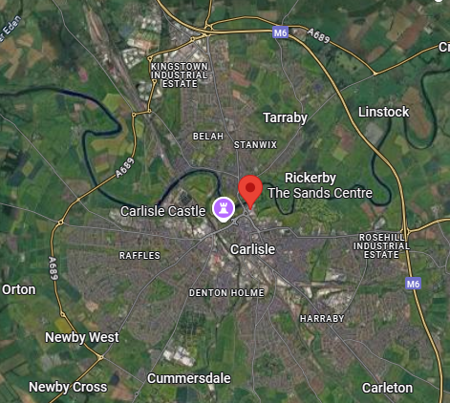

The Centre is located next to Hardwicke Circus roundabout.

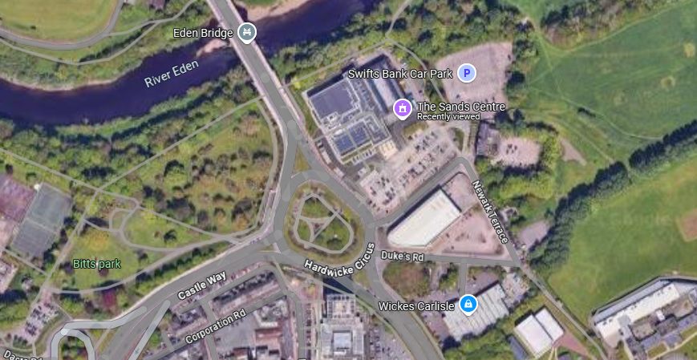

* From the North, exit the M6 at J44 and follow the signs for the city centre. Take the first exit at the Hardwicke Circus roundabout.
* From the East and South, enter the city via J43 on to Warwick Road. Turn right on to Victoria Place then continue until the right turn on to Georgian Way. Take the right lane and then on to Hardwicke Circus. At the roundabout, take the third exit.
* From the West, follow the signs for the city centre. Head past the Castle, on to Hardwicke Circus and take the second exit.

# Parking

Parking is available at The Sands Centre and a number of near by car parks. The maps below show 3 locations for parking. Please avoid using the parking in the surrounding businesses as you may incur a penalty charge.

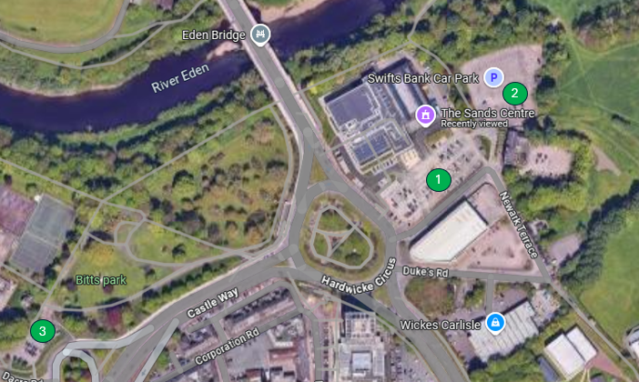

Parking 1 is at The Sands Centre, directly at the front of the building. There is a charge for parking which is payable at the pay and display meters.

Parking 2 is at the Swifts car park which is next to the building. There is a charge for parking which is payable at the pay and display meters.

Parking 3 is at Bitts Park and is about 400m from the registration and main building. This is more limited in space but close to the event if the other two are full.

There is also parking in and around the city centre and all within a few minutes walk of the registration and transition areas.

# Timetable

|  |  |
| --- | --- |
| **Action** | **Timing** |
| **Registration open**  *Please register in plenty of time and don’t leave it until the last minute as this puts pressure on you as a competitor and the registration team.* | 7:00 – 7:45 |
| **Transition open**  *Please ensure you have your wristband, bike and helmet number visible and your helmet fastened when entering transition.* | 7:10 |
| **Transition close**  *Transition will close 15 minutes before the start to ensure people can attend the mandatory race briefing*. | 7:45 |
| **Race Briefing**  *The briefing is mandatory. Full details are provided in this pack and a verbal briefing will be given to all competitors on the day.* | 7:45 |
| 1st swim wave start | 8:00 |
| 2nd swim wave start | 8:10 |
| 3rd swim wave start | 8:25 |
| 4th swim wave start | 8:40 |
| **Event close and road fully re-open**  *The facility will be open until 16:00 but the road will be fully re-opened after the 12:00 cut off point.* | 12:00 |

# Facilities

The Sands Centre is a purpose built leisure facility and has excellent access in, around and throughout the site. Step free access is available to all areas of the building. The main entrance is via a covered walkway and accessed directly from the main car park. You can enter the building and head to the rear where registration and transition will be set up.

Competitors have exclusive use of the pool and changing facilities before the event. The centre will be open to other users from 8:00 though (excluding the pool area). There are both individual and group changing facilities available with enough to accommodate everyone. The pool area has individual shower cubicles for use for competitors after the event; these are also within the pool changing area. There are also lockers you can use in the pool changing area, with others situated directly outside in the corridor and upstairs near the gym area. Lockers require a £1 coin to operate which is returned after use.

# Registration

Registration will be open from 7:00. Please arrive as early as possible to avoid any delays to the start of the event. The registration area will be to the rear of the building. At registration, you will need be asked to provide **PHOTO ID** and either a **British Triathlon Member ID** or a **British Triathlon Race Pass**. You will not be able to collect your race pack without these.

For further information on race passes or how to purchase one, please see the link here: [Carlisle Triathlon – British Triathlon](https://www.britishtriathlon.org/events/carlisle-triathlon_16513)

At registration, competitors will receive the following:

* Race Number: to be displayed on your back of your body when on the bike and the front during the run (race belts are recommended)
* Race number stickers
  + 1 x Bike sticker to be wrapped around the seat post
  + 1 x Helmet sticker to be attached to the front of your helmet
  + 1 x Wristband with number
* Race timing chip: to be attached to your left ankle and worn throughout the race
* Swim cap: this will be either white, grey or yellow

After collecting your race pack, please ensure enough time to rack in transition and flag to any of the marshals if you require assistance. Please note that all race timing chips must be returned at the end of the race or you will incur a charge for any that are not returned. A marshal will indicate where to place these at the end of the race.

# Race Briefing

The Carlisle Tri Club Triathlon, 2025 in partnership with Better Leisure Ltd is here. This is the Cities first triathlon for almost 6 years. We believe we have brought out the best the City has to offer with a state of the art facility, part closed roads, fast cycle course and flat run course. The event is designed to entice the first time competitor and seasoned athlete alike.

The event is being held early on a Sunday morning. This means roads and paths will be quieter but you must take care **AT ALL TIMES** during the race and follow both the Highway code and Countryside code. Anyone found not following these will be subject to disqualification.

**Swim starts** will be staggered and based on your estimated times you stated when entering. You will be in a lane with 2 other people of a similar speed. Each swimmer will be set of in 10 second intervals. If you catch the person in front, you should indicate you wish to pass by ‘toe touching’. The swimmer in front should then allow the person behind to pass at the next swim end. There are a total of 8 lanes and a one way system in place in each lane. Swimmers in each lane will also swim in either a clockwise or anti-clockwise direction, alternating for each lane. A marshal will count your distance and indicate when you are on your last length/25m so you know when to exit the pool. The swim is 500m which is 20 lengths of the pool. When exiting the pool, there is none slip tiling is in place but please take care. You will exit the pool via the door and down on to the ramp directly at transition. If you get in to trouble, relax, turn on to your back and hold your hand in the air. There are trained lifeguards at pool side who will assist you as needed.

***Transition map***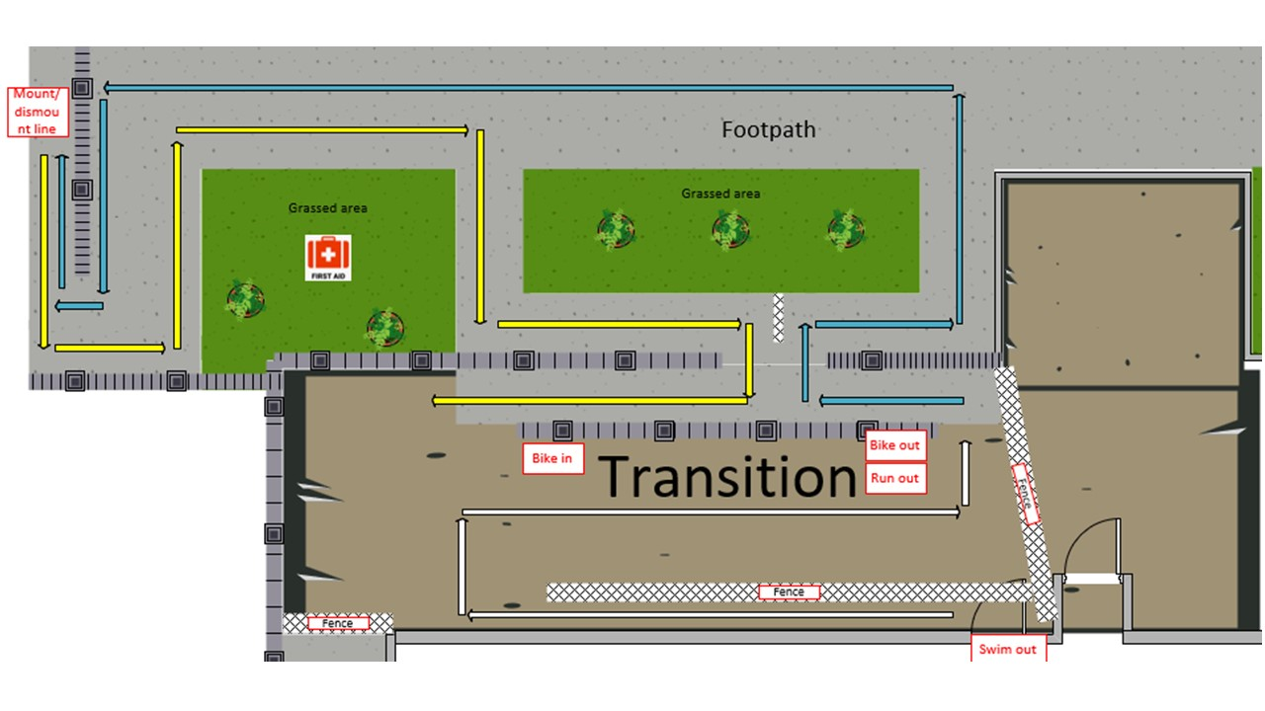

**Transition** is a one way system. You will head down the ramp to the end of a fenced area before turning right in to transition. Here you can transition to your bike gear and exit via the ‘Bike Out’ signs. Make sure your race number is visible on your back. Please do not un-rack your bike until you have fastened your helmet. Leaving transition, you will have 40m section before the mount line. There are a couple of turns but the path is smooth and wide enough to accommodate the most high tech of machinery! The mount line will have marshals to aid you. Please do not mount your bike until after this point. As you mount your bike, you will be on a section of closed road riding against the traffic. Please stay to the left and follow the highway code. During the first 800m, there is a strict **NO OVERTAKING ZONE**. Please do not overtake until you enter Rickerby Park or on the way back in toward the end of the bike leg.

**The bike course** is a fast course with three main turning points. All are clearly signposted and marshalled but is it your responsibility to know the course and follow the highway code at all times. Marshals will not stop traffic for you and you may need to slow down or stop if required. The three main turn points are;

* Rickerby Park – right hand turn at 800m from the start
* Linstock roundabout – third exit at the roundabout
* Carlisle airport roundabout – third exit and return

You will not be crossing traffic and should stay left. This section is fast with good or excellent road surface throughout but please take care. When coming up to the Carlisle airport roundabout, you will need to take the centre of the road and indicate that you are turning right to any following traffic.

As your head back, your will enter the road closure section again for the last 800m where the no overtaking zone will be in place. Take care at the dismount line and return in to transition via the right hand path, indicated by the ‘Bike In’ signs. You will enter the one way system in transition again and ensure your bike is racked BEFORE removing your helmet.

Once you have racked your bike and kit, you can exit transition via the ‘Run Out’ signs. This is the same exit point as the bike out previous.

The run course takes you out over the bridge and into Rickerby Park. There is a cattle grid on the way into the park with a gate to the left-hand side. This gate will be open to avoid you having to navigate the cattle grid. There is a looped section by the monument which will be sign-posted and marshalled at each turn point. Please keep left on the paths and be courteous to other park users. Towards the end of the looped section, you will be given a wristband to indicate you have completed it before returning past the monument and over the second bridge. Once over the bridge, you will take a right on to the path that follows the river all the way back to the finish which is directly at the rear of the centre next to transition.

# Transition information

Competitors should be racked and have left transition by 7:45.

Access to Transition will be via the rear of The Sands Centre. You can get to transition by heading through the main reception area and following the centre to the right. Transition will be outside through the double doors. There will be marshals at the entrance to the transition area who will be able to help you out as needed. Please ensure race number stickers are attached to your bike and helmet and please wear your race number on your person to gain access (wristband). Marshals at the entrance to transition will check the Race Number on your kit/race belt and helmet matches the number on your bike.

Only entrants with a visible and corresponding Race Number on their bike will be allowed access to the transition area. Do not enter transition without permission from a Marshal and do not ride in transition. No spectators, family or friends will be allowed in transition. The use of mobile phones, cameras and MP3 players is NOT PERMITTED in the transition area.

You should lay out your equipment next to your bike and, if the weather is poor, you can keep your kit in a small waterproof bag to keep your kit dry. Please keep the area around your bike and in transition tidy and clear of obstructions. Please note that kit boxes are not permitted in transition. During the event you need to take care and pay attention in the transition area. Always keep a keen eye out for other competitors and if the weather is wet or inclement please take your time and slow down.

Helmets must be worn and fastened before un-racking bikes - ***do not mount your bike until after crossing the Bike Mount line.*** On re-entering transition, ***dismount your bike before crossing the Dismount line.*** Do not unfasten your helmet until you have racked your bike.

There must be no nudity in transition – you must wear appropriate clothing so as to avoid a full change of clothes or ensure you are fully covered if you need to change.

These are British Triathlon Competition Rules and will be closely monitored in and around the Transition area by Marshals and British Triathlon Officials in attendance

Finished participants will be able to access transition to collect their kit whilst the event is in progress but during busy periods you may be asked to briefly wait so as to allow transition to clear and to not impede other competitors who are still racing - please be patient and follow to marshal instructions at all times.

# Swim information

You will enter the pool from the changing rooms at the bottom of the diagram below. Entry to the pool will be via the right-hand side as indited on the diagram. Each lane will swim in an opposite direction and avoid and clashes (land 1 clockwise, lane 2 anticlockwise and so on). Competitors will be in a lane with swimmers of a similar pace and set off in 10 second intervals. If you catch the person in front, touch their toes. This indicates you wish to pass. If you are caught and ‘toe touched’, please allow the swimmer behind to pass you at the next end of the pool. Swim marshals will be situated to the left-hand side and indicate to you when you are on your final length. You will then exit via the same side you entered and out to the transition area as shown below.

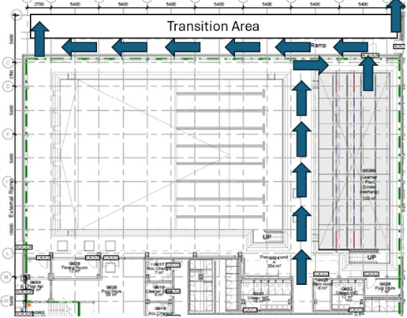

# Bike Information

The bike course used a selection of quite roads and slightly busier sections. It is a Sunday morning race where traffic is quieter but please take care. There is a no overtaking zone in place for the first and last 800m of the course. This is in the road closure section to allow for as much space as possible during the section. There are two cattle grids when you enter and exit the park, please take caution when crossing them. All turn points will be clearly sign posted and marshalled. Any adjoining roads will have warning signs for other road users but it is our responsibility to ensure you follow the highway code and are prepared to slow down or stop if required. Marshals can not stop traffic. There will be a tail rider following the last competitor.

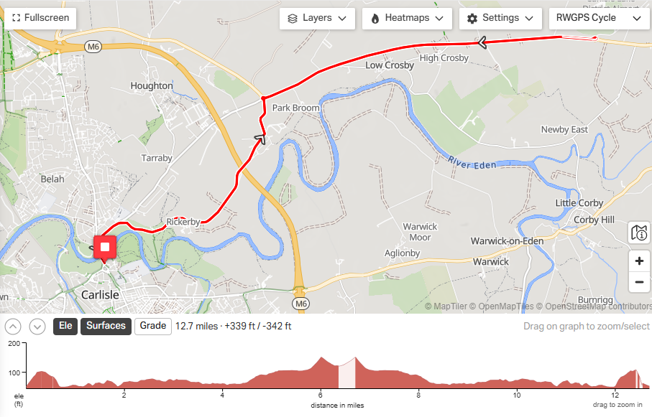

The link to the route can be found in the link here: [Carlisle Triathlon Bike Course · Ride with GPS](https://ridewithgps.com/routes/48864677)

# Run Information

The route image is shown below. Each turn point will have a marshal and signage indicating where to turn. The loop shown on the map is the ‘triangle’ section. The North Eash point is where you will be handed the wristband to indicate you have completed the section. There is a road closure in place through the park but there may be other walkers in the area so please be courteous to other park users. The paths are all of good or excellent quality and wide enough to accommodate multiple users.

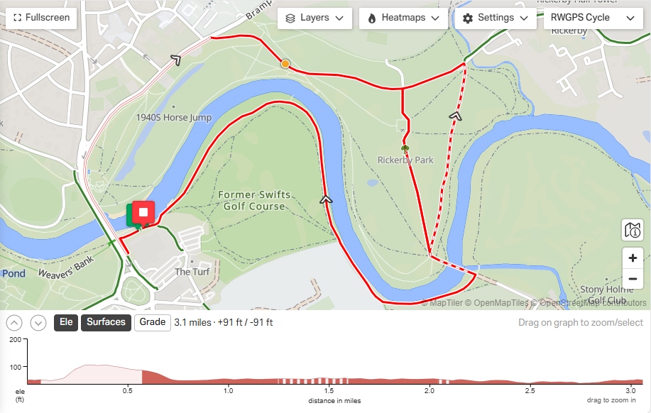

The link to the run route can be found here: [Carlisle Triathlon Run · Ride with GPS](https://ridewithgps.com/routes/50002860)

# Other information

**Medical Support and Safety on Race Day**

Your safety is our top priority. On race day, trained safety crews will be present throughout the event. A dedicated First Aid hub will be located behind The Sands Centre, next to the transition area, and a mobile first responder will be patrolling the course. Additionally, we are just one mile from the nearest hospital should further medical assistance be required.

**Important Health Guidance**

* Do not participate if you are feeling unwell. It’s always better to rest and return stronger another day.
* If you begin to feel unwell during the event, stop immediately and alert an event official so medical staff can assist you.
* Please do not ignore symptoms such as chest pain, dizziness, headaches, nausea, diarrhea, or any other signs of distress.
* If you have a pre-existing medical condition, we strongly recommend consulting your doctor before taking part.

**Medical Information for Emergencies**

If you have any medical conditions, please write full details—including current medications—on the back of both of your race numbers. This information is vital in case of an emergency. There is a dedicated medical number to cal

**Hydration**

To stay safe and perform at your best, it’s important to manage your hydration throughout the event. Participants are strongly encouraged to carry their own fluids on both the Bike and Run courses, as needed. It is your responsibility to ensure you stay properly hydrated. Please also avoid consuming alcohol the night before the event, as it can significantly affect your hydration levels and overall performance.

**Relay rules**

To ensure a smooth race day experience, please carefully read the following guidelines for relay teams:

* All relay team members must attend registration together.
* Each team member must present valid ID, British Triathlon Licence, or a Race Pass.
* At registration, each team will receive:
  + 1 timing chip (used as the relay baton)
  + 2 race numbers (one for the cyclist, one for the runner)
  + 1 bike number sticker
  + 1 helmet sticker
  + Wristband number
* The cyclist must wear their race number on their back.
* The runner must wear their race number on their front.

**Relay Procedure**

* The swimmer starts the race with the timing chip on their ankle.
* After completing their section, they run into transition and pass the timing chip to the next team member:
* The next athlete must secure the timing chip on their left ankle before starting their leg of the race. Cyclists may be fully dressed and ready with their helmet on while waiting, but must not touch their bike until the chip is in place.
* After completing the bike leg, the cyclist returns to transition, racks their bike, and hands the chip to the runner.
* The runner then attaches the chip to their left ankle and begins the final leg.
* The swimmer and cyclist are welcome to wait at the end of the finish chute to join their runner and cross the finish line together.

**Withdrawal during the event**

If you need to withdraw from the event at any point before reaching the finish line, it is essential that you inform an official at either the **Registration Area** or the **Finish Area**. You must also return your timing chip when doing so. This helps us ensure the safety and accountability of all participants.

**Nudity**

In line with British Triathlon regulations, **nudity is strictly prohibited at all times during the event**. This includes:

* Changing clothes in the transition area.
* Being topless at any point on the course.
* Having your tri suit unzipped and hanging down during the bike or run segments.

Please ensure you remain appropriately covered throughout the event to avoid disqualification.

**Baggage**

There are lockers which can be used inside The Sands Centre. These are not marshalled by Carlisle Triathlon and all kit left is done so at your own risk.

**Prizes**

* Open: 1st, 2nd, 3rd
* Female: 1st, 2nd, 3rd
* Open Vet 40, 50, 60 and 70: 1st
* Female Vet 40, 50, 60 and 70: 1st
* 1st Relay Team (min entry 3 teams)

**Spectators**

We warmly welcome spectators to come along, cheer on the participants, and enjoy the event atmosphere. Your support means a lot to the athletes!

However, please be considerate of competitors during the race:

* Be aware of your surroundings and step aside when triathletes are approaching.
* Do not be offended if asked to move—this is to ensure the safety and smooth flow of the race.
* Please avoid gathering around the transition area or other busy sections of the course where space is limited and athlete movement is critical.

**BTF rules**

The race will take place in accordance with British Triathlon Competition Rules. These are available HERE and must be abided by at all times. The Rules are in place for the safety and enjoyment of all competitors, spectators, marshals and officials.